Individual assignment 1
You need to plot shear force and bending moment diagrams for the beams below. In addition, you need to find maximum values of deflections and stresses for each beam. Consider that beams are made of materials given in Table 1. A cross-section of all beams is presented in figure 1. The height of the cross-section is 0,2 m, the width is 0,1 m. The thickness of the beam is 0,05 m.
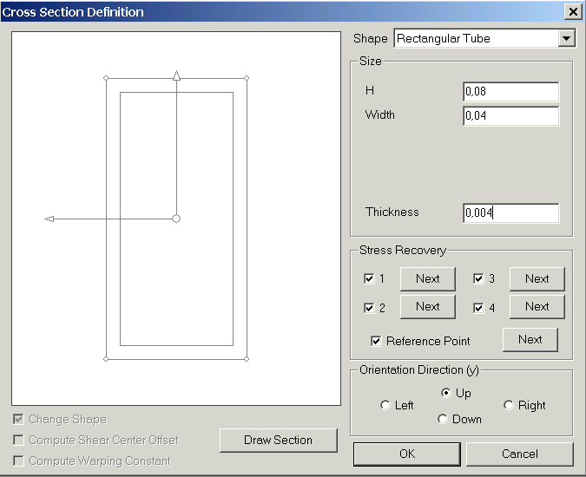
0.2 m
0.1 m
0.05 m
Figure 1. Cross-section of beams

Accept the following values of constants in calculations:
,
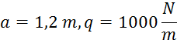
Table 1. Mechanical properties of materials
Variant № | Material | Density, kg/m³ | Young Modulus, GPa | Poisson’s ratio | Yield strength, MPa | Compressive strength, MPa | Tensile strength, MPa
1,5,10, 15,20 | Structural Steel | 7850 | 210 | 0,3 | 220 | 250 | 250
2,6,11, 16, | Aluminum Alloy | 2770 | 71 | 0,33 | 250 | 280 | 280
3,7,12, 17 | Copper | 8300 | 110 | 0,34 | 260 | 280 | 280
4,8,13, 18, | Stainless Steel | 7750 | 193 | 0,31 | 180 | 207 | 207
9,14,19 | Titanium Alloy | 4620 | 96 | 0,36 | 820 | 900 | 900

Schemes of beams with loads and constraints for all variants are presented below.
F₂

1
2
3
F₁
q₂
q₁
F₂
M₁
q₂
q₂
M₂
M₁
M₁
q₂
q₂
M₂
q₁
M₂
F₁
F₁
q₁
M₁
F₁
M₂
M₂
M₁
M₁
q₁
q₂
F₂
M₂
q₁
q₂
q₁
q₂
q₁
M₂
M₂
F₁
a
a
a
a
a
a
a
F₂
F₁
F₁
F₂

q₂
q₂
q₂
q₂
q₂
q₂
4
5
6
M₁
M₂
q₁
q₂
M₂
M₁
F₁
F₂
F₁
F₂
M₂
M₂
M₁
F₁
M₂
F₂
q₁
q₂
M₁
M₂
q₁
q₁
q₂
M₁
F₁
M₂
M₂
M₂
M₁
M₁
a
a
a
a
a
a
a

q₂
q₂
q₂
7
q₂
8
9
q₂
q₂
q₁
q₁
q₂
M₂
M₁
F₂
F₁
M₁
M₂
M₁
M₂
q₁
M₂
M₂
F₁
F₂
M₂
M₁
q₁
q₂
M₂
M₁
F₂
F₁
a
a
a
a
a
a
a
M₂
M₂
M₁

10
11
12
q₂
q₂
q₂
q₂
q₂
q₂
M₂
M₁
F₁
F₂
F₂
q₁
M₁
M₂
F₁
F₂
M₁
M₁
M₂
F₂
q₁
q₂
q₂
M₂
M₁
F₁
F₂
q₁
q₂
M₂
F₁
F₂
M₁
a
a
a
a
a
a
a
F₁
M₂
q₁

13
14
15
q₂
q₂
q₂
q₂
q₂
q₂
q₂
q₁
q₁
F₂
F₁
F₁
F₁
F₂
F₂
F₁
F₂
F₁
F₁
F₂
q₁
q₁
q₂
M₁
M₂
M₂
M₁
M₁
M₁
M₂
M₁
M₂
M₁
M₂
M₂
M₂
a
a
a
a
a
a
a
M₁
M₂
F₁
M₂
F₁
M₂
F₁
16
17
18
M₁
F₂
M₂
F₂
M₁
F₂
q₂
q₂
q₂
q₂
q₂
q₂
q₂
q₁
q₂
M₂
F₂
M₂
F₂
M₁
M₁
F₁
F₂
q₁
q₂
q₂
q₁
q₁
F₂
M₁
F₂
a
a
a
a
a
a
a
M₂

M₂
F₁
M₁
F₁
19
20
M₂
M₂
F₁
M₁
q₂
q₂
q₂
q₂
q₁
M₁
F₂
F₂
M₁
q₁
q₁
q₂
q₂
M₁
F₂
M₁
F₂
a
a
a
a
a
a
a
q₂

